**JAYPEE UNIVERSITY OF INFORMATION TECHNOLOGY**

**WAKNAGHAT**

**Operating Systems Lab**

**Lab Assignment dated 28.01.2022**

**Name -** Akash Kumar Singh

**Roll no -** 201460

**Batch -** CS 48

**Task 1: WAP to display the following output using fork( ) and getpid( ) functions/system calls:**

#include<stdio.h>

#include<unistd.h>

int main()

{

printf("Hello World!\n");

fork();

printf("I am after forking\n\tI am process %d.\n",getpid());

return 0;

}

**//Output –**

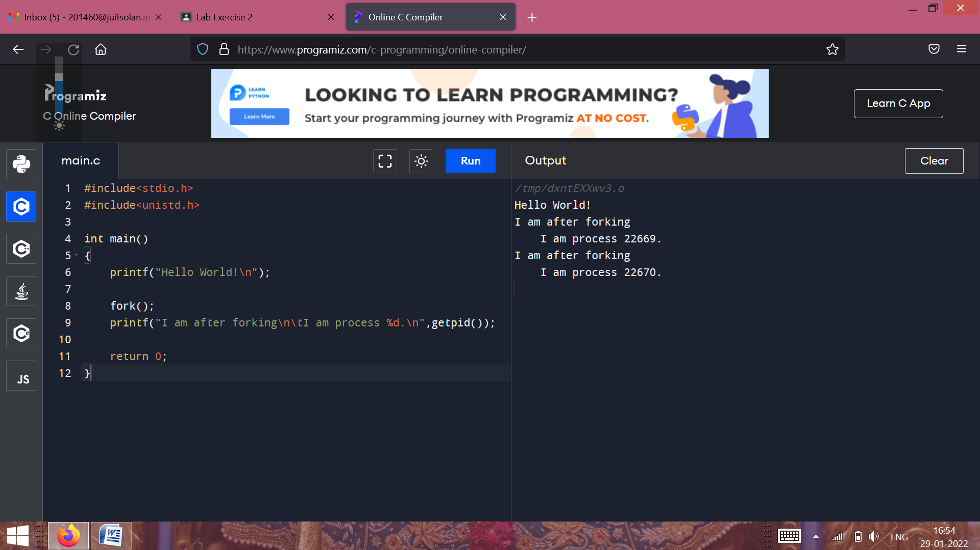

**Task 2: WAP to display the following output using fork( ) & getpid( ) functions/system calls:**

#include<stdio.h>

#include<unistd.h>

int main()

{

printf("Hello World!\n");

printf("I am the parent process and pid is : %d.\n",getpid());

printf("Here I am before use of forking\n");

int rvalue=fork();

if(rvalue==0)

{

printf("Here I am just after forking\n");

printf("I am the child process and pid is : %d.\n",getpid());

}

else if(rvalue>0)

{

printf("Here I am just after forking\n");

printf("I am the parent process and pid is : %d.\n",getpid());

}

return 0;

}

**//Output –**

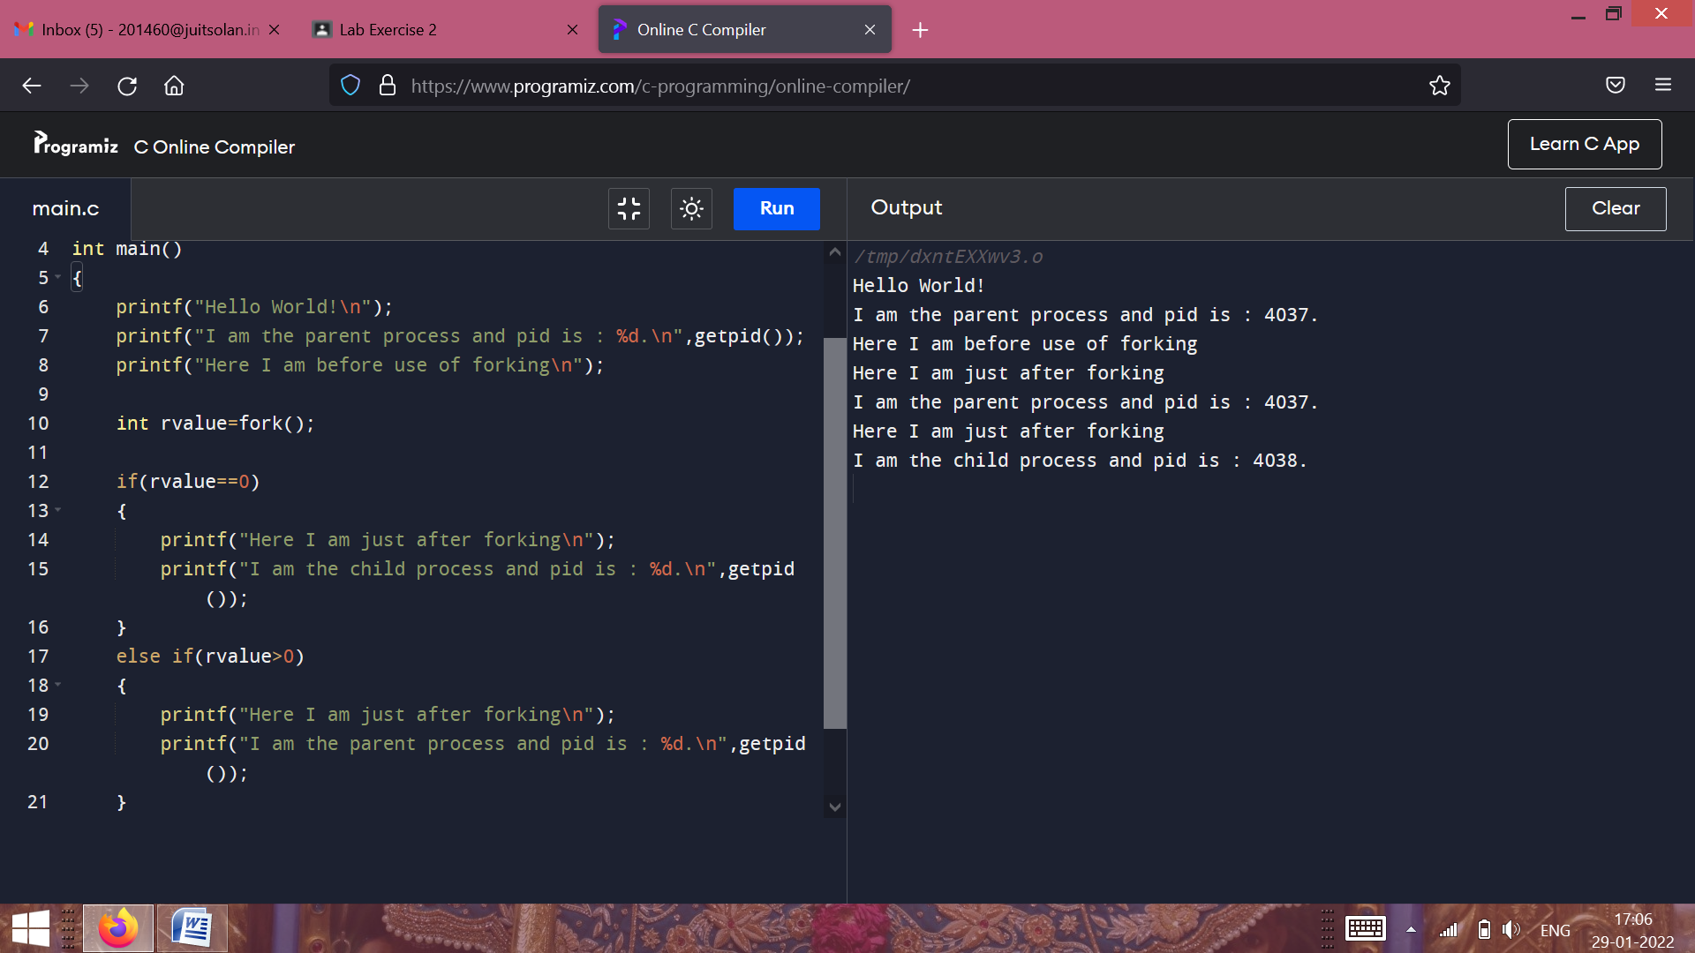

**Task 3: WAP to display the following output using fork( ), getpid( ) & getppid( ) functions/system calls:**

#include<stdio.h>

#include<unistd.h>

int main()

{

fork();

printf("I am the current process %d and my parent process is %d\n",getpid(),getppid());

return 0;

}

**//Output –**

